OT Professional Event Paper
Lindsay Houlihan
OT-562-G
Professor Morgan Villano, MPA, MSPS, OTR/L
April 10th, 2025

AOTA Inspire 2025 Conference
Walking into a conference as a 21-year-old first year occupational therapy student (OTS), is much easier said than done. Anticipating the environment of being surrounded by over 8,000 occupational therapists from all different specialties, settings, and backgrounds is a lot to take in for the first time ever. Our three-hour drive gave myself and my peers to discuss and prepare for what we were going to experience over the next three days. The nervousness mixed with the excitement was at points overwhelming, yet something that I took to prepare myself for the future as practitioners where we will often encounter circumstances of uncertainty and intense pressure.
Attending the AOTA INSPIRE 2025 Annual Conference & Expo in Philadelphia was a transformative experience that significantly influenced my intentions for future professional development. The conference not only enhanced my understanding of occupational therapy (OT) but also reshaped by perceptions of professional commitment, involvement, and engagement. In just three days, this experience has greatly influenced my attitudes, intentions, and perceptions about the importance of engaging in our profession beyond the classroom.
Being surrounded by thousands of OTs, attending multiple informative sessions, and connecting with numerous vendors in the exhibit hall, I have grown a further passion for the potential I have in engaging in the profession of OT. The Theory of Planned Behavior plays a significant role in shaping one’s intention to engage in specific behaviors (Ajzen, 1991). Prior to attending the conference, I had a general interest in continuing my education through conferences and workshops, such as ConnOTA, but I did not fully understand the scope of opportunities that would directly impact my practice. The exposure to new and upcoming research and the passion of the speakers influenced my attitude toward active participation in professional events. I now feel more motivated to attend future conferences and workshops to stay current with OT revolutions and to contribute to discussions within the professional community.
One of the most powerful aspects of the conference was the opportunity to observe and interact with experienced practitioners, educators, and students who share a common passion to advancing the field of OT. In the theory of planned behavior, subjective norms are the perceived social pressures to engage in a particular behavior (Ajzen, 1991). The presence of so many experienced professionals highlighted the commitment that individuals within the OT profession have toward advancing the field. I found it fascinating that so many participants were willing to invest their personal time into these efforts, and strive to be able to do the same, as my knowledge continues to expand. This demonstrated a culture of voluntary involvement, something that is very common in the profession of OT (Walder et al., 2022). It became evident that attending professional events is not just about personal gain, but also the reciprocity of giving back to the community. This shared commitment reinforces the importance of professional networks and fosters a sense of belonging within the OT profession.
Attending the AOTA INSPIRE 2025 Conference has significantly impacted my attitudes toward professional engagement and my intention to participate more fully in the OT community. Through the lens of the theory of planned behavior, I have gained an in-depth understanding how attitudes, subjective norms, and behavioral control influence my professional involvement. The experience has not only increased my confidence in the contribution of OT associations btu also has inspired me to strive for leadership roles that can help shape the future of the profession. I now recognize that active involvement in these associations is crucial for the continued growth and advocacy of OT, and I am committed to engaging in this process moving forward.

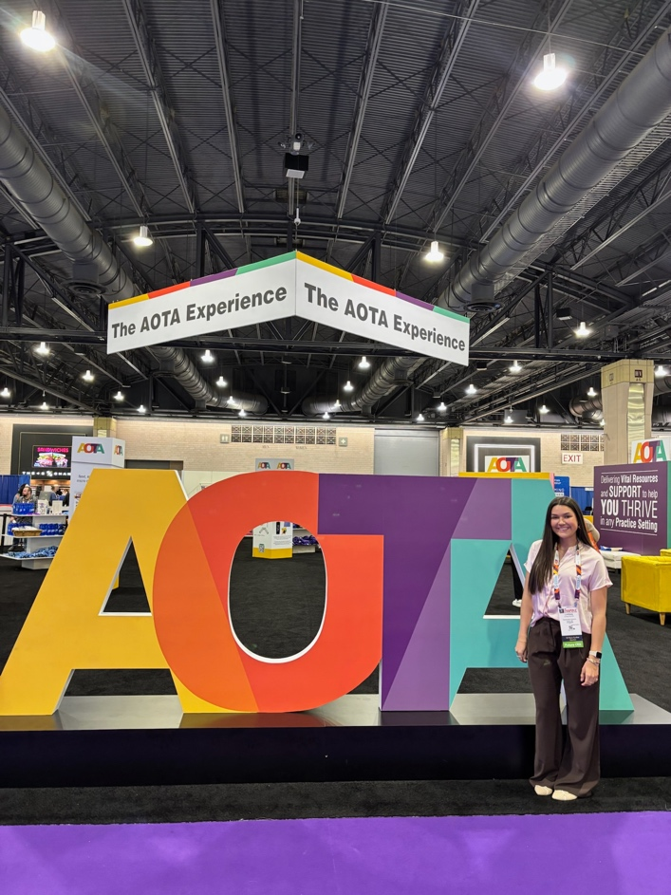
*Proof of Attendance*

References
Ajzen, I. (1991). The theory of planned behavior. Organizational Behavior and Human Decision Processes, 50, 179-211.
Walder, K., Bissett, M., Molineuz, M., & Whiteford, G. (2022). Understanding professional
identity in occupational therapy: A scoping review. Scandinavian Journal of Occupational Therapy, 29(3), 175-197.

